Freshdesk user guide

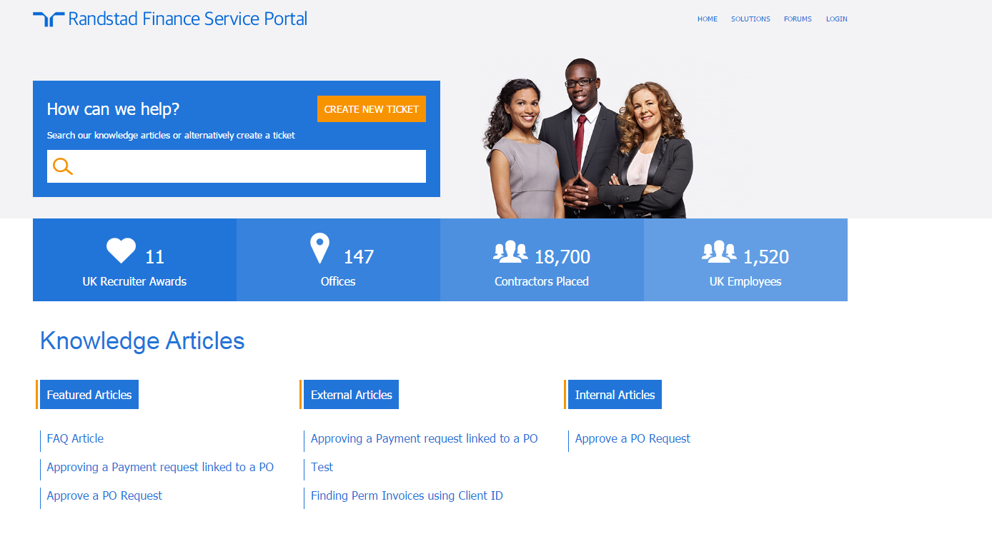

Logging in to Freshdesk

Click Login

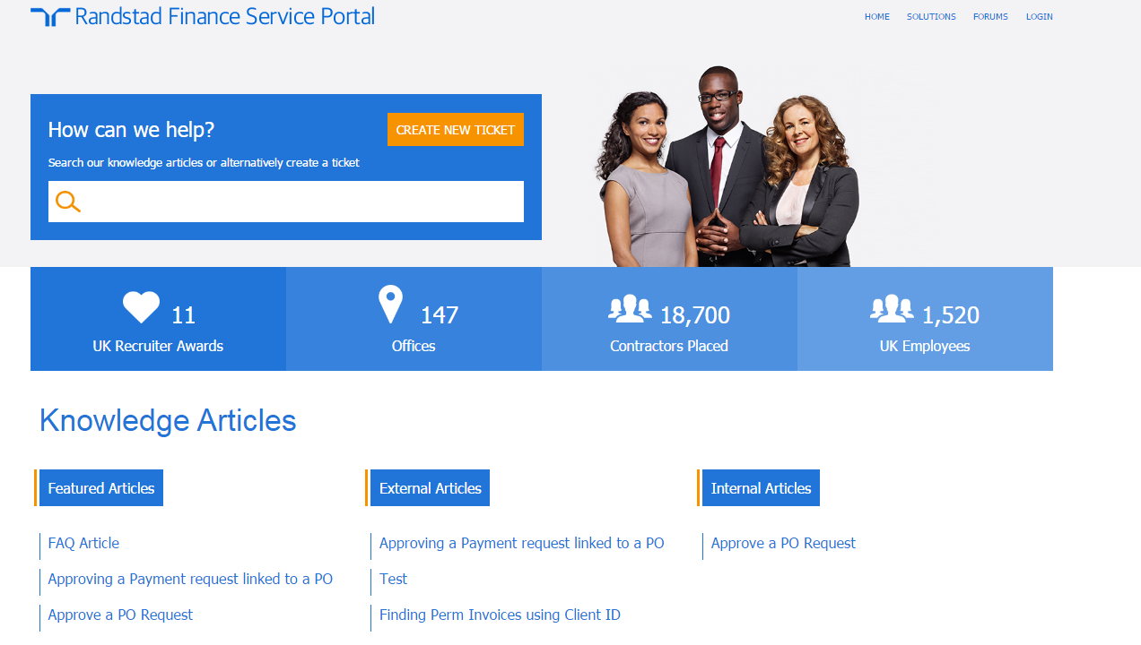

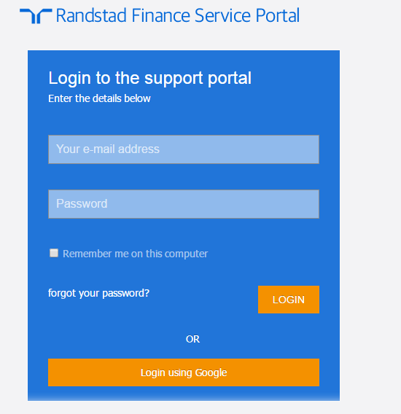

Click Login Using Google and this will automatically log you in.

Creating a ticket

Click on Create New Ticket

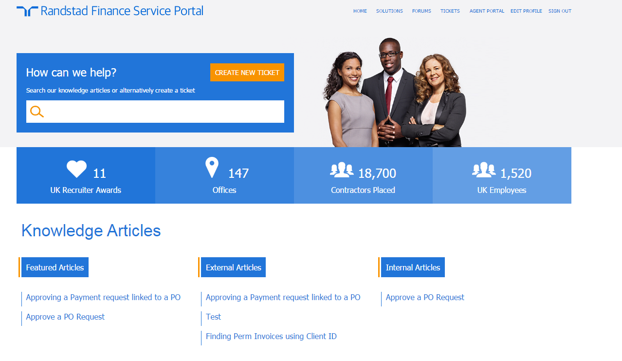

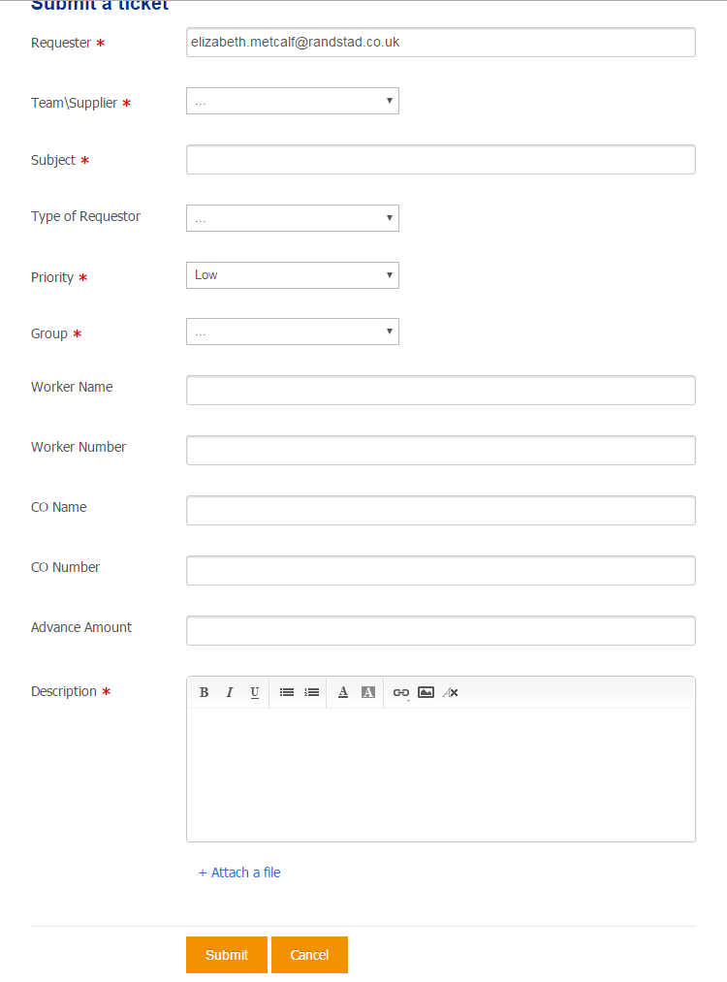
Once the above has been completed, click submit.
Files can be attached to support the query.
Please enter as much detail as possible here.
Please fill in as much as possible here.
Duplicate Team/Supplier
Select the priority as per the classifications
This can be left blank
Enter the subject

From the dropdown select cpeadvances for an advance request, CIS Scoping to refer a worker to Emma/Mark for scoping or Payroll for all other queries.

This will default to your email address

Once you have submitted your query, you will receive an email confirming a ticket has been raised. This will also contain your ticket number and a link to the ticket so you can view this at any time:

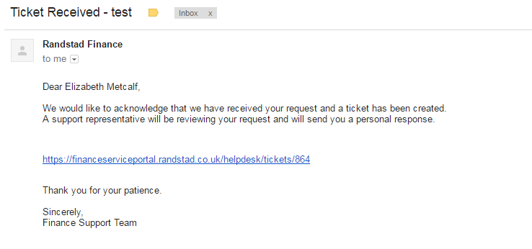

You will receive a notification each time your ticket is updated and again when it is resolved/closed.

