Locate Perm Record by Client ID

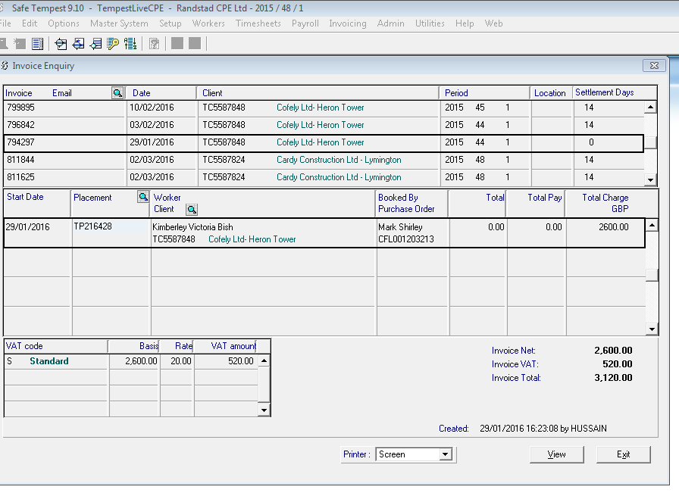

Invoice Enquiry
Click second icon along Locate Record
Move to Client field
Right Click Paste (if in clipboard)

